**Markup Utilities**

March 2017 – Version 1.0

Contents

1. Markup Utilities **3**

1.1 Supported Versions3

1.2 Category3

1.3 Permissions4

1.4 Special Considerations4

2. Deployment**4**

3. Input and Preparation**4**

3.1 Workspace installation 5

3.2 Creating manager and worker agents6

4. Running the solution**6**

4.1 Exporting Markups 6

4.2 Importing Markups 8

4.3 Reproducing Markups 10

4.4 Markup Utility File  11

4.5 History  11

4.6 Markup Utility Type 12

4.7 Load File Template 12

5. Viewing results and history**14**

5.1 Export Job 14

5.2 Import Job 14

5.3 Reproduce Job **15**

6. Handling errors **15**

7. Uninstalling application**1****6**

8. Notes**16**

8.1 Source Code Solution 16

8.2 Unit Tests 17

8.3 Mapping Markups from External Sources 17

9. Disclaimer**1****7**

# 

# 1. Markup Utilities

This workspace-level Relativity solution allows users to export, import and reproduce redactions across workspaces within the same environment as well as other environments. Redactions can be migrated to and from any Markup Sets within the workspace. Reproduce functionality allows for redaction duplication across relational groups or document sets within a workspace.

## 1.1 Supported Versions

This solution is supported in Relativity versions 9.4.254.2 and higher.

## 1.2 Category

This custom solution consists of the following components:

* Relativity Application
* Relativity Dynamic Objects (RDO’s)
  + Markup Utility Export Job
  + Markup Utility Import Job
  + Markup Utility Reproduce Job
  + Markup Utility File
  + Markup Utility History
  + Markup Utility Type
* Relativity Agents
  + Export Manager
  + Export Worker
  + Import Manager
  + Import Worker
  + Reproduce Manager
  + Reproduce Worker
* Object Rules
* Event Handlers
  + Custom objects (RDO’s)
    - Console
    - Pre-Save
    - Post-Save
    - Pre-Cascade Delete
  + Relativity Application
    - Post-Install
* Custom Pages
* SQL working tables
* Unit tests for all components

## 1.3 Permissions

• Permissions for this solution have not been implemented. Users interested in using this application will need to configure permissions manually.

## 1.4 Special Considerations

Before you deploy and run the solution, it's important to keep the following in mind:

* Audit Records are created for each individual markup that is created.
* Revert functionality for both the Import and Reproduce Jobs has not been implemented. The source code identifies areas where logic is required. If adding coverage to the code base, please make sure to add supporting unit tests.

# 2. Deployment

To deploy and configure the solution, you must first add it to the Application Library as a Relativity application. You can then install and configure the solution in a workspace.

To add the solution application to the Application Library:

1. Log in to Relativity.

2. Click the user drop-down menu in the upper-right corner of Relativity, then click Home.

3. Click the **Applications & Scripts** tab, then click the **Application Library** tab.

4. Click **Upload Application**.

5. Click **Browse**, navigate to and select the MarkupUtilities.rap file, then click **Open**.

6. Click **Save**.

# 3. Input and Preparation

After you add the solution application to the Application Library, you're ready to install and configure it in a workspace by performing these basic tasks:

• Workspace installation (if necessary)

• Create manager and worker agents (if necessary)

## 3.1 Workspace installation

To install the application into a Workspace:

1. Click the user drop-down menu in the upper-right corner of Relativity, then click **Home**.

2. Click the **Applications & Scripts** tab, then click the **Application Library** tab.

3. Click the name of the **Markup Utilities** application.

4. Under **Workspaces Installed**, click **Install**.

5. Click next to Workspaces.

6. Select the destination workspace(s) and click **Ok**.

7. Click Save.

8. If you encounter any errors while installing (see image below). Click each Error link in the Status column.

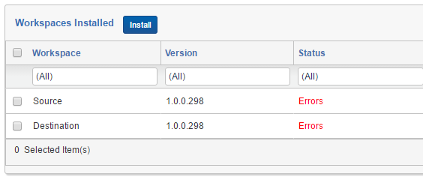

9. In the Source – Errors popup window, check each of the **Unlock** checkboxes and click the **Retry Import** button. This will give the application rights to continue with the installation into the selected Workspaces.

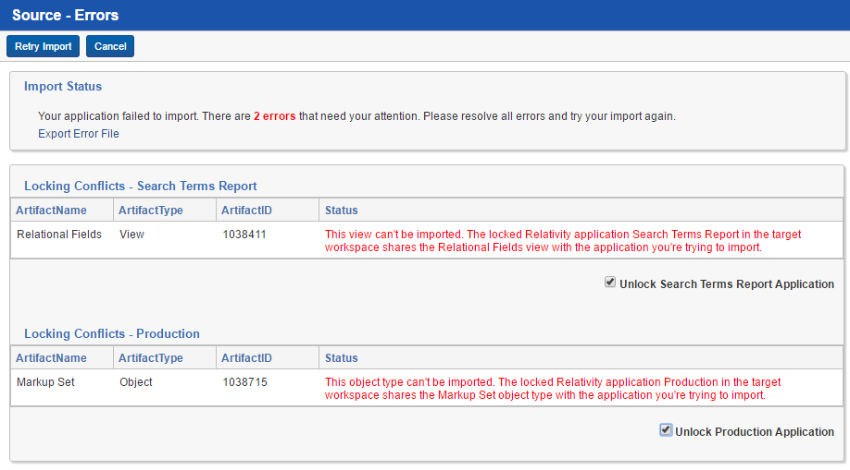

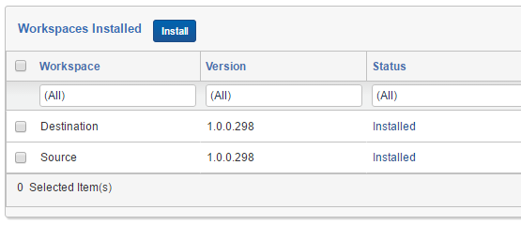

## 3.2 Creating manager and worker agents

To create manager and worker agents, perform the following steps:

1. Click the user drop-down menu in the upper-right corner of Relativity, then click **Home**.

2. Navigate to the **Server & Agent Management** tab, then select **Agents** and click **New Agent**.

3. Click next to **Agent Type**, select **Markup Utilities - Export Manager**, and click **Ok**.

4. Set the number of manager agents you want in the **Number of Agents** field.

5. Click next to **Agent Server** and select the agent server where you want to install the new agent. Click **Ok**.

6. Set the appropriate interval.

7. Leave all other settings at their default values and click **Save and New**.

8. Repeat steps 2-7 for the following Relativity Agents:

* **Markup Utilities - Export Worker**
* **Markup Utilities - Import Manager**
* **Markup Utilities – Import Worker**
* **Markup Utilities – Reproduce Manager**
* **Markup Utilities – Reproduce Worker**

**Note:** Agent types respect resource pools. If you do not add agents to the agent servers on which your workspaces reside, no data will be processed.

Agents are not limited to work off-hours. They can run at any point throughout the day.

# 4. Running the solution

This section will describe the steps required to export, import and reproduce markups in a Workspace.

## 4.1 Exporting Markups

1. Navigate to the **Markup Utilities** tab and click the **Export Job** tab.
2. To create a new Export Job, click the **New Markup Utility Export Job** button.
3. Enter values for the following required fields:
   1. Name: The name of the Export Job.
   2. Saved Search: The name of the Saved Search that contains the documents with redactions that you are requesting.
   3. Markup Set: The Markup Set that contains the redactions you are requesting.
   4. Redaction Type: A list of redaction types you are requesting for the export.

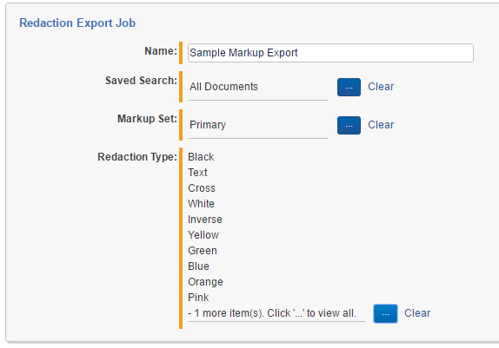

1. Click **Save**.
2. To submit the Export Job for processing, click the **Submit** button in the console.

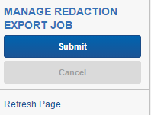

1. Verify the progress of the Export Job Agents by refreshing the page and viewing the **Status** field in the **Export Progress** category.

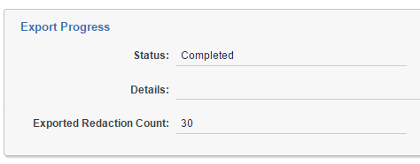

1. If any errors are encountered while exporting, the **Status** field will indicate an error and the **Details** field will contain more information. Additional error details will also be located in the Errors tab within Relativity. One last location for Export Job errors is the MarkupUtility_ExportErrorLog table located in the EDDS database.
2. Once an Export Job has completed successfully, a new .csv file containing the requested markups will be created and stored in the Redaction File field within the Export File category. The successful completion will also create a new Markup Utility File RDO record in the same Workspace. You can then export the csv located in the new Markup Utility File RDO record (to be used in another Workspace within the same or different environments) or re-use the Markup Utility File RDO record in an Import Job where markups are applied to another Markup Set within the same Workspace.

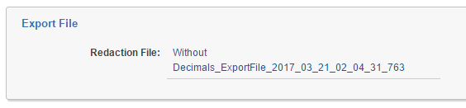

## 4.2 Importing Markups

1. Navigate to the **Markup Utilities** tab and click the **Import Job** tab.
2. To create a new Import Job, click the **New Markup Utility Import Job** button.
3. Enter values for the following required fields:
   1. Name: The name of the Import Job.
   2. Markup Set: The Markup Set which you would like markups imported into.
   3. Redaction Type: A list of redaction types you are requesting to be imported from the load file.
   4. Skip Duplicate Redactions: Check this field if you want to skip the import of any duplicate redactions on the Document. Un-check this field if you want duplicate markups to be applied to the Documents.
   5. Redaction File: This contains a link to the associated Markup Utility File RDO record which contains the import csv file.

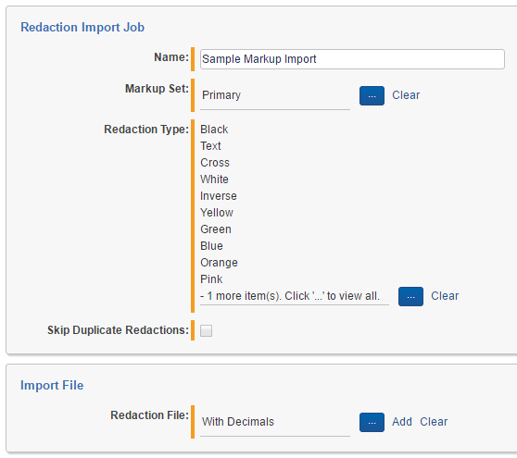

1. Click **Save**.
2. To validate the format of the import csv file, click the **Validate** button in the console.

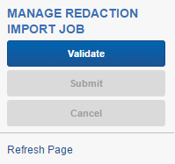

1. Once the file has successfully passed the validation, click the **Submit** button in the console to initiate the importing of markups.

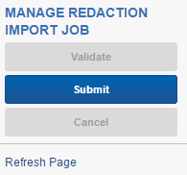

1. Verify the progress of the Import Job Agents by refreshing the page and viewing the **Status** field in the **Import Progress** category.

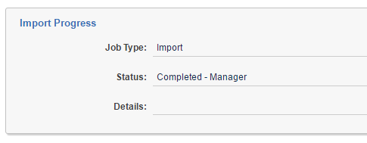

1. The Redaction Counts category contains numerous values indicating the quantity of redactions that we in the import file, the expected amount based on the Import Job settings and the actual number of markups that were imported. If any markups were skipped, that value will also be noted in this section. If any errors are encountered, the count will be displayed and an error record is created.

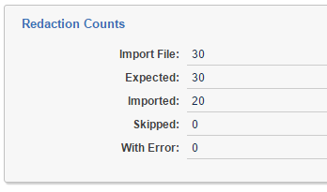

1. If you are interested in obtaining a log of all the activity during the Import Job, please check the Markup Utility History (Import Job) category which lists each redaction that was slated to be imported along with a status.

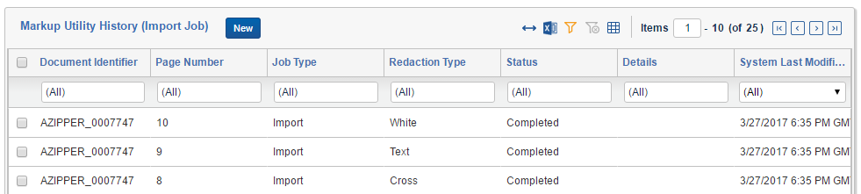

## 4.3 Reproducing Markups

If you would like to reproduce redactions within a Workspace from one Markup Set to another based on a Document set or relational group use the Reproduce Job RDO. No load files are required for this feature.

1. Navigate to the **Markup Utilities** tab and click the **Reproduce Job** tab.
2. To create a new Reproduce Job, click the **New Markup Utility Reproduce Job** button.
3. Enter values for the following required fields:
   1. Name: The name of the Reproduce Job.
   2. Reproduce Job Type: This is used to identify whether the reproduction spans across relational groups or Document Sets.
   3. Saved Search: This identifies the Document set to be used for the Reproduce Job.
   4. Source Markup Set: The Markup Set which is used as the source of Markups.
   5. Destination Markup Set: The Markup Set which markups will written to.
   6. Relational Field: This field identifies the relational group field for the Document object when using the **Across Relational Group** choice for the **Reproduce Job Type** field.
   7. Has Auto Redactions Field: This field identifies whether the document has auto redactions applied to it when the reproduction is complete.

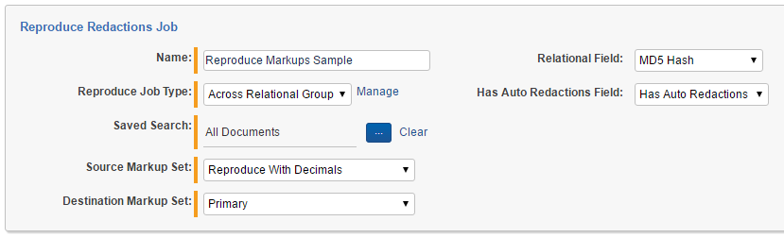

1. Click **Save**.
2. To submit the Reproduce Job for processing, click the **Submit** button in the console.

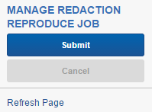

1. Verify the progress of the Reproduce Job Agents by refreshing the page and viewing the **Status** field in the **Reproduce Progress** category.

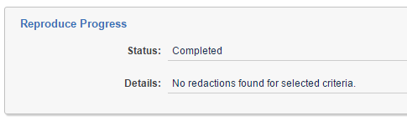

## 4.4 Markup Utility File

This RDO was created to manage the csv files that were created by the successful completion of an Export Job. It was also created to load any import csv files where markups were created in a separate workspace (within the same or different Relativity environments) or from an external non-Relativity system.

1. Navigate to the **Markup Utilities** tab and click the **Export Job** tab.
2. To create a new Export Job, click the **New Markup Utility Export Job** button.
3. Enter values for the following required fields:
   1. Name: The name of the Markup Utility File.
   2. File: Select the appropriate csv file that contains the markups you are interested in importing. Please make sure that the csv file conforms to the provided csv template.
4. Click **Save**.
5. This record is now ready to be associated with a new Import Job record.

## 4.5 History

For the Import, Export and Reproduce Jobs, once the Submit button is clicked on the console, the application will begin processing the request. All activity will be tracked in the History RDO. If at any point in time you would like to review the history, you can view this RDO and filter for the specific job you are interested in. You can also navigate to the Import or Export Job and view the details. A History category should be available in the View mode. As of this writing, a link to the Reproduce Job history items does not exist.

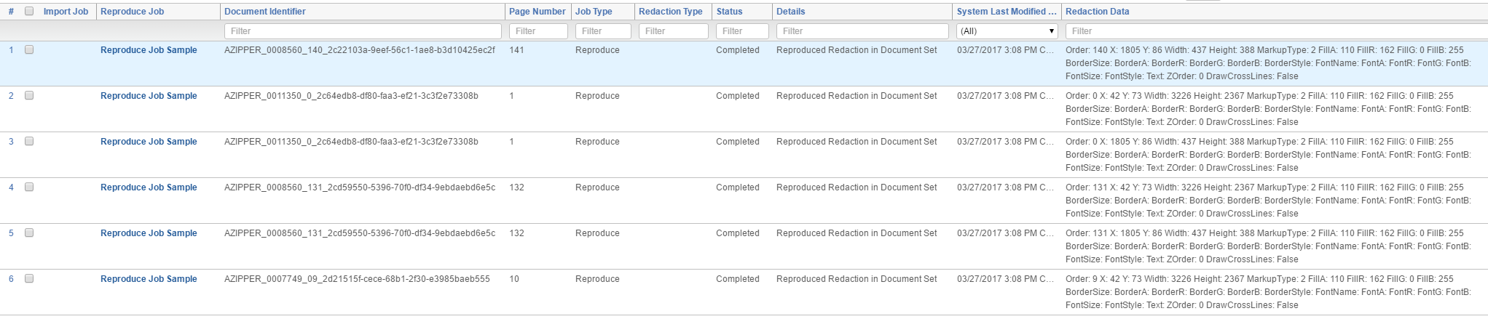

## 4.6 Markup Utility Type

The Markup Utility Type RDO contains a list of Redaction Markup Sub Types for each type of Redaction Type (Category). Please do not alter these values unless an explicit change is made in Relativity.

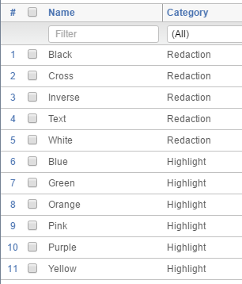

## 4.7 Load File Template

When this solution exports markups from a Workspace, a .csv file is created and attached to the completed Export Job. When you would like to import markups from a Relativity environment or an external system, a load file is required. The markups that have been exported and those slated for export are in the following format.

|  |  |  |
| --- | --- | --- |
| **Column Name** | **Data Type** | **Description** |
| DocumentIdentifier | String | This the unique document identifier for the Document that has markups applied. Typical values are stored in the ControlNumber or DocIDBeg fields. |
| FileOrder | Integer | This field identifies which page of the Document contains the individual markup. This is a zero-based field which means page one of a Document is equal to 0. |
| X | Integer | This is the x coordinate value of the upper left corner for the rectangular markup. For a full page markup, set this value to 0. |
| Y | Integer | This is the y coordinate value of the upper left corner for the rectangular markup. For a full page markup, set this value to 0. |
| Width | Integer | This is the width (in pixels) for the rectangular markup. For a full page markup, set this value to -1. |
| Height | Integer | This is the height (in pixels) for the rectangular markup. For a full page markup, set this value to -1. |
| MarkupType | Integer | This identifies whether the markup is a redaction or highlight. Redactions will have a value of 1 while highlights will have a value of 2. No other values are acceptable. |
| FillA | Integer | The alpha value representing the opacity of the markup. Acceptable values are between 0 and 255. A value of 0 indicates a completely transparent fill while a value of 255 indicates a completely opaque fill. |
| FillR | Integer | The value identifying how much red is applied to the markup. Acceptable values are between 0 and 255. A value of 0 indicates completely transparent while a value of 255 indicates a completely red color. |
| FillG | Integer | The value identifying how much green is applied to the markup. Acceptable values are between 0 and 255. A value of 0 indicates completely transparent while a value of 255 indicates a completely green color. |
| FillB | Integer | The value identifying how much blue is applied to the markup. Acceptable values are between 0 and 255. A value of 0 indicates completely transparent while a value of 255 indicates a completely blue color. |
| BorderSize | Integer | The border size of the markup in pixels. |
| BorderA | Integer | The alpha value representing the opacity for the markup border. Acceptable values are between 0 and 255. A value of 0 indicates a completely transparent border while a value of 255 indicates a completely opaque border. |
| BorderR | Integer | The value identifying how much red is applied to the markup border. Acceptable values are between 0 and 255. A value of 0 indicates a completely transparent border while a value of 255 indicates a completely red border. |
| BorderG | Integer | The value identifying how much green is applied to the markup border. Acceptable values are between 0 and 255. A value of 0 indicates a completely transparent border while a value of 255 indicates a completely green border. |
| BorderB | Integer | The value identifying how much blue is applied to the markup border. Acceptable values are between 0 and 255. A value of 0 indicates a completely transparent border while a value of 255 indicates a completely blue border. |
| BorderStyle | Integer | This value represents the border style applied to the markup. Acceptable values are the following: 1: None  2: Solid  3: Dash  4: Dot  5: DashDot  6: DashDotDot |
| FontName | String | This value represents the font name used for markups containing text. The default value is Arial. |
| FontA | Integer | The alpha value representing the opacity for the font. Acceptable values are between 0 and 255. A value of 0 indicates a completely transparent font while a value of 255 indicates a completely opaque font. |
| FontR | Integer | The value identifying how much red is applied to the markup text. Acceptable values are between 0 and 255. A value of 0 indicates a completely transparent text while a value of 255 indicates a completely red text. |
| FontG | Integer | The value identifying how much green is applied to the markup text. Acceptable values are between 0 and 255. A value of 0 indicates a completely transparent text while a value of 255 indicates a completely green text. |
| FontB | Integer | The value identifying how much blue is applied to the markup text. Acceptable values are between 0 and 255. A value of 0 indicates a completely transparent text while a value of 255 indicates a completely blue text. |
| FontSize | Integer | The value identifying the font size applied to the markup text. A value of -1 is defaulted to Auto. |
| FontStyle | Integer | This value represents the font style applied to the markup text. Acceptable values are the following: 1: Regular  2: Bold  3: Italic  4: Strikeout  5: Underline |
| Text | String | This is the text that will be displayed in the markup text. |
| ZOrder | Integer | The value is related to inverse redactions. A value of 0 is the standard markup (non-inverse). A value of -2147483648 represents an inverse redaction with an associated MarkupSubType = 6. |
| DrawCrossLines | Integer | This value represents whether cross lines are written on the redaction. Acceptable values include 0 (do not draw cross lines) and 1 (draw cross lines). |
| MarkupSubType | Integer | This value represents the markup subtype. Values representing colors are applied to Markup Types = Highlights. Acceptable values are the following: 1: Black  2: Yellow  3: Text  4: Cross  5: White  6: Inverse  7: Green  8: Blue  9: Orange  10: Pink  11: Purple |
| X_d | Decimal | This is the x coordinate value of the upper left corner for the rectangular markup in a decimal format. For a full page markup, set this value to 0.0000. |
| Y_d | Decimal | This is the y coordinate value of the upper left corner for the rectangular markup in a decimal format. For a full page markup, set this value to 0.0000. |
| Width_d | Decimal | This is the width (in pixels) for the rectangular markup in a decimal format. For a full page markup, set this value to -1.0000. |
| Height_d | Decimal | This is the height (in pixels) for the rectangular markup in a decimal format. For a full page markup, set this value to -1.0000. |

# 5. Viewing results and history

## 5.1 Export Job

1. Navigate to the **Markup Utilities** tab and click the **Export Job** tab.
2. The **All Markup Utility Export Jobs** View will display a number of fields associated with the RDO. To track the status of the Export Job, view the **Status** field. If the job has encountered any errors, information will be located in the **Details** field.

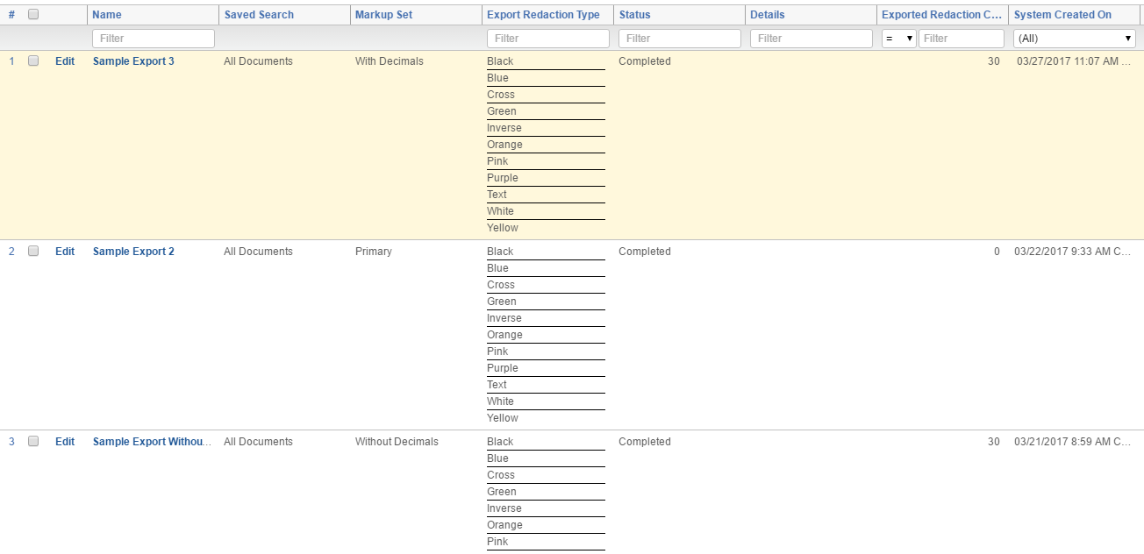

## 5.2 Import Job

1. Navigate to the **Markup Utilities** tab and click the **Import Job** tab.
2. The **All Markup Utility Import Jobs** View will display a number of fields associated with the RDO. To track the status of the Import Job, view the **Status** field. If the job has encountered any errors, information will be located in the **Details** field.

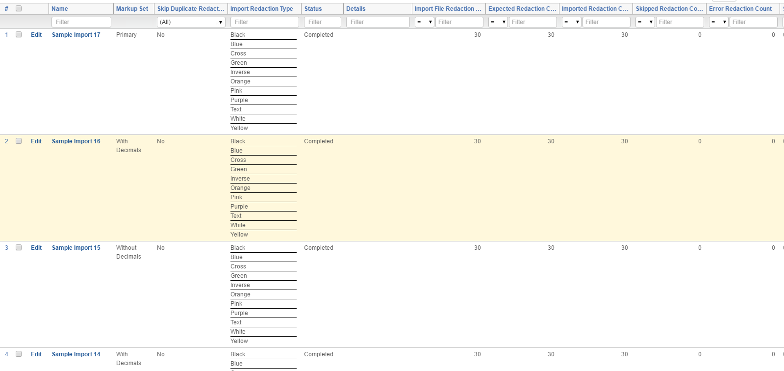

## 5.3 Reproduce Job

1. Navigate to the **Markup Utilities** tab and click the **Reproduce Job** tab.
2. The **Reproduce Job** View will display a number of fields associated with the RDO. To track the status of the Reproduce Job, view the **Status** field. If the job has encountered any errors, information will be located in the **Details** field.

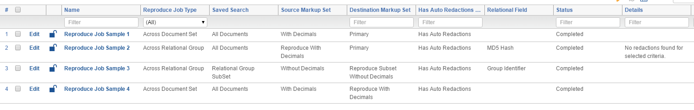

# 6. Handling errors

1. There are three locations where errors can be tracked for this solution.

1. Relativity Errors tab
   1. Navigate to the **Errors** tab within the Admin section of Relativity.
2. History RDO:
   1. If errors are not displayed in the Errors tab of Relativity, the next place to look is the History RDO for the solution. Filter for the specific Import, Export or Reproduce Job for further details.
3. SQL:
   1. If no errors are displayed in the History RDO, the last place to look is within the SQL database. Individuals with access to the SQL environment should navigate to the EDDS database and look in any of the following three tables for additional details.
      1. For the Import Job, query the **MarkupUtility_ImportErrorLog** table.
      2. For the Export Job, query the **MarkupUtility_ExportErrorLog** table.
      3. For the Reproduce Job, query the **MarkupUtility_ReproduceErrorLog** table.

# 7. Uninstalling application

1. The Markup Utilities application performs just like any standard Relativity Application. There are no special steps required to uninstall the application. If for any reason you uninstall this application from a Workspace and you want to retain the data that is stored in any of the RDO’s that are part of the project, please make sure to identify those components prior to uninstalling. This is accomplished by unchecking the objects just before initiating the uninstallation. The uninstallation of this project will not affect any of the markups (redactions) that have already been applied to any documents.

# 8. Notes

## 8.1 Source Code Solution

The source code for this solution consists of the following projects. If you plan to alter the source code and re-post to the public repository, it is recommended to keep the structure as consistent to the original as possible.

1. MarkupUtilities.Agents
   1. This project contains the original source code for the Export, Import and Reproduce Manager and Worker agents. For each Manager and Worker agent there are two classes. The first class is the actual Relativity agent (i.e. ExportManager.cs). The second one is the job class that contains all of the business logic for the specific agent (i.e. ExportManagerJob.cs). The purpose of this design is to separate the logic so that the individual Job class can be unit tested.
2. MarkupUtilities.Agents.NUnit
   1. This project contains all the unit tests for the Export, Import and Reproduce Relativity agents.
3. MarkupUtilities.CustomPages
   1. This MVC project contains logic to display the status of the Agent Manager and Worker SQL queue tables.
   2. Although this feature is part of the project, it is not implemented in the Relativity Application. Feel free to investigate and add to your instance. It was included as an example of how Custom Pages can be implemented into your application. A typical use for Custom Pages like this project include dashboards which provide insight into the health and progress of all included solution components, Relativity Agents in this scenario.
4. MarkupUtilities.CustomPages.NUnit
   1. This project contains all the unit tests for the Custom Pages project.
5. MarkupUtilities.EventHandlers
   1. This project contains all the business logic for any Relativity Event Handler applied to the solution’s RDO’s or the application.
   2. As with the MarkupUtilities.Agents project, the project has been designed with main Event Handler classes and associated Job classes that are used when executing the NUnit tests.
6. MarkupUtilities.EventHandlers.NUnit
   1. This project contains all the unit tests for the Event Handler project.
7. MarkupUtilities.Helpers
   1. This project contains helper classes which consist of constants, connections to the RSAPI, SQL connections and more.
   2. Guids for all application components are located in the Constant.cs class. Please make sure not to alter these if you are making modifications to the application. The main reason to change Guids is for situations when you are interested in creating a completely different application while maintaining some of the original structure of the application.
8. MarkupUtilities.Helpers.NUnit
   1. This project contains all the unit tests for the Helpers project.

## 8.2 Unit Tests

Each of the Visual Studio projects have an associated project that contains unit tests. If you are making changes to the application, please make sure to add additional unit tests that will cover your new logic and not impact previous code or unit tests. After you have added your tests, run the entire suite of tests and make sure new and old tests pass. Once all tests have passed, you can then submit a request to commit your changes to the public repository.

## 8.3 Mapping Markups from External Sources

When migrating markups from non-Relativity systems into Relativity, markups may not match up exactly as they are displayed in other systems. This could be due to multiple items such as image resolution, how redactions are stored in the source system and much more. We highly recommend if you are using this system to migrate markups, please make sure to test and cross-check your data. At the time of this writing, Relativity only supports rectangular dimensions.

# 9. Disclaimer

This solution is intended for use only in the Relativity versions specified in this document and run under the guidelines presented. While each solution is carefully built and thoroughly tested to work on the versions of Relativity specified in this document, this script is not a core feature of Relativity and is not eligible for the same level of support as the Relativity platform.

In addition, custom components may not exhibit the same performance and behavior as native Relativity features. Custom solutions do not specify permission settings unless explicitly requested by the client.